______________________________________________________________

UM-SJTU JOINT INSTITUTE

PHYSICS LABORATORY

(VP 241)

______________________________________________________________

LABORATORY REPORT

EXERCISE 5

RC, RL, AND RLC CIRCUITS

|  |  |  |
| --- | --- | --- |
| **Name: Weikai Zhou** | **ID: 518021911039** | **Group: 8** |
| Name: Yingtao Zou | ID: 518370910069 | Group: 8 |
|  |  |  |
| Date: 15 November 2019 |  |  |

1. **Introduction [1]**
   1. **Objectives**

* Try to understand the physics of alternating-current circuits, in particular the processes of charging/discharging of capacitors, the phenomenon of electromagnetic induction in inductive elements, and other dynamic processes in RC, RL, and RLC series circuits.
* Study methods for measuring the amplitude-frequency and the phase-frequency characteristics of RC, RL, and RLC series circuits.
* Try to find the resonance frequency of a RLC circuit as well as the quality factor of the circuit from the amplitude-frequency curve.
  1. **Theoretical background**

The basic elements of electric circuits are resistors, capacitors, and inductors. *RC*, *RL*, *RLC* alternating-current (AC) circuits will display various features, including transient, steady state, and resonant behavior, based on the particular arrangement of these elements.

* + 1. **Transient processes in *RC*, *RL*, *RLC* series circuits**
       1. ***RC* series circuits**

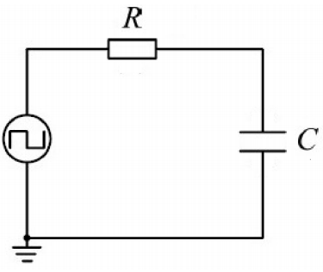One example of a transient process is the process of charging or discharging of the capacitor in a RC circuit. The figure below shows a *RC* series circuit in which a square-wave signal is used as the source signal (Figure 1).

Figure 1. *RC* series circuit

We can see that the square-wave voltage is $U\left(t\right)=ε$ in the first half of the cycle. And it charges the capacitor. The square-wave voltage is zero in the second half of the cycle. And the capacitor discharges itself through the resistor. We can derive the loop equation (Kirchhoff’s loop rule) for the charging process as

$$RC\frac{dU_{C}}{dt}+U_{C}=ε. (1)$$

If the initial condition $U_{C}\left(t=0\right)=0$, the solution of Eq. (1) can be found as

$$U_{C}=ε\left(1-e^{-\frac{t}{RC}}\right) and{ U}_{R}=iR=εe^{-\frac{t}{RC}}.$$

Then, we can find that the voltage across capacitor $U_{C}$ increases exponentially with time *t*, 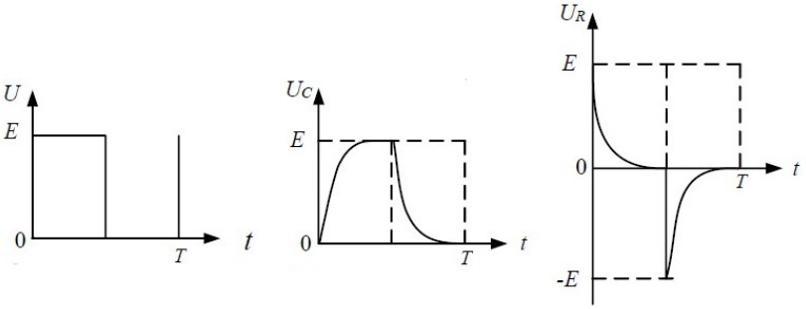while the voltage on the resistor $U_{R}$ decreases exponentially with time *t*. The curves $U\left(t\right)$, $U_{C}\left(t\right)$ and $U_{R}\left(t\right)$ are shown in Figure 2.

Figure 2. Charging/discharging curves for a RC series circuit

In the discharging process, the loop rule gives us

$$RC\frac{dU_{C}}{dt}+U_{C}=0. (2)$$

If the initial condition $U_{C}\left(t=0\right)=ε$, the solution of Eq. (2) can be found as

$$U_{C}=εe^{-\frac{t}{RC}} and U_{R}=iR=-εe^{-\frac{t}{RC}},$$

where the magnitude of both $U_{C}$ and $U_{R}$ decrease exponentially with time. We call $RC=τ$ the *time constant* and characterizes the dynamics of the transient process because it has the units of time. Another characteristics related to the time constant called the *half-life period $T_{1/2}$*  is easier to measure in experiments. It means the time needed for $U_{C}$ to decrease to a half of the initial value (or increase to a half of the terminal value). And we may use it to characterize the dynamics of the transient process. In the process with exponential dynamics discussed above, both quantities are related by the equation that

* + - 1. ***RL* series circuit**

We can carry a similar analysis for *RL* series circuit and get that

* + - 1. ***RLC* series circuit**

When a power source is suddenly plugged into a *RLC* circuit, the voltage across the capacitor satisfies the differential equation that based on the loop rule

$$LC\frac{d^{2}U_{C}}{dt^{2}}+RC\frac{dU_{C}}{dt}+U_{C}=ε. (3)$$

If we divide both sides of equation by $LC$ and introducing the symbols that

$$β=\frac{R}{2L} and ω_{0}=\frac{1}{\sqrt{LC}}, (4)$$

we can simplify Eq. (3) as

$$\frac{d^{2}U_{C}}{dt^{2}}+2β\frac{dU_{C}}{dt}+ω_{0}^{2}U_{C}=ω_{0}^{2}ε. (5)$$

We should note that Eq. (5) is an inhomogeneous differential equation and it is mathematically equivalent to the equation of motion of a damped harmonic oscillator with a constant driving force. If $β$ is the damping coefficient and $ω_{0}$ is the natural angular frequency, the complementary homogeneous equation is fully analogous to the equation of motion of a damped harmonic oscillator. Moreover, after a specific solution to the inhomogeneous equation is found, a unique solution to the initial value problem consisting of Eq. (5) and the initial conditions can be found as

$$U_{C}\left(t=0\right)=0 and {\left.\frac{dU_{C}}{dt}\right|}_{t=0}. (6)$$

There are 3 regimes, depending on the relation between $β$ and $ω_{0}$ for mechanical oscillations, as implied by the solution of the complementary homogeneous equation:

* $β^{2}<ω_{0}^{2}$ (weak damping): the system is in the underdamped regime and the solution to the initial value problem is of the form:

$$U_{C}=ε-εe^{-βt}\left(\cos{ωt}+\frac{β}{ω}\sin{ωt}\right),$$

where $ω=\sqrt{ω_{0}^{2}-β^{2}}$.

* $β^{2}>ω_{0}^{2}$ (strong damping): the system is in the overdamped regime with the solution of the form

$$U_{C}=ε-\frac{ε}{2γ}e^{-βt}\left[\left(β+γ\right)e^{γt}-\left(β-γ\right)e^{-γt}\right],$$

where $ω=\sqrt{β^{2}-ω_{0}^{2}}$.

* $β^{2}=ω_{0}^{2}$: the system is in the critically damped with the solution of the form

$$U_{C}=ε-ε\left(1+βt\right)e^{-βt}. (7)$$

We will suddenly remove the power source ($ε=0$) when the circuit reaches a steady state. The differential equation for the discharging process is similar to that of the charging process, and there are also three regimes of the process.

The discussion above is true for an ideal circuit and a step-signal source with zero internal resistance. However, during the experiment, we use a square-wave source with a small internal resistance as the ideal case. We need to remember that the period of the square-signal must be much greater than the time constant of the circuit. And we should also note that no matter what the regime is, the voltage across the capacitor will finally reach $ε$ (Figure 3).

Figure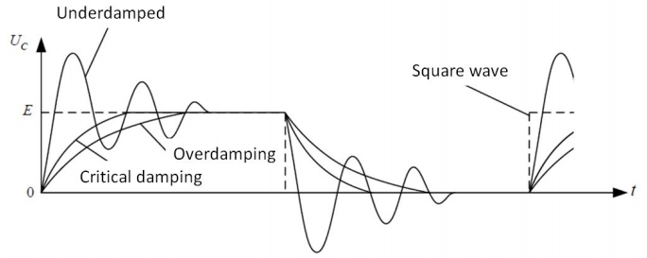 3. Three different regimes of transient processes in a *RLC* series circuit

* + 1. ***RC*, *RL* steady-state circuits**

Usually, the amplitude and the phase of the voltage across the capacitor and the resistor will change with the frequency of the input voltage when a sinusoidal alternating input voltage is provided to a *RC* (or *RL*) series circuit. We can measure the voltage across the elements in the circuit for different input signal frequencies to obtain the amplitude vs. frequency relation and the phase vs. frequency relation.

* + 1. ***RLC* resonant circuit**
       1. ***RLC* series circuit**

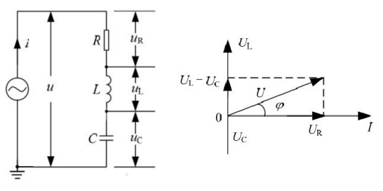The figure below shows a generic *RLC* series circuit (Figure 4).

Figure 4. *RLC* series circuit

Using the phasors technique, we can easily calculate the impedance and the phase difference in the *RLC* circuit. The phase differences between the current and the voltages across the resistor, coil, and capacitor can be calculated as below if we represent the current *I* by a vector along the horizontal axis.

$$φ_{R}=0, φ_{L}=\frac{π}{2}, φ_{C}=-\frac{π}{2}.$$

Then, the corresponding voltage amplitudes across the elements are

$$U_{R}=IZ=IR, U_{L}=IZ_{L}=IωL, U_{C}=IZ_{C}+\frac{I}{ωC}.$$

Therefore, the voltage amplitude can be calculated as below

$$U=\sqrt{U_{R}^{2}+{\left(U_{L}-U_{C}\right)}^{2}} or U=I\sqrt{R^{2}+{\left(ωL-\frac{1}{ωC}\right)}^{2}}, (8)$$

and the total impedance is

$$Z=\sqrt{R^{2}+{\left(ωL-\frac{1}{ωC}\right)}^{2}}, (9)$$

and the phase difference between the current and the voltage in the circuit is

* + - 1. **Resonance**

If the frequency of the input signal provided by the source satisfies the condition that

$$ω_{0}L=\frac{1}{ω_{0}C}, or, equivalently, ω_{0}=\frac{1}{\sqrt{LC}},$$

the total impedance will reach a minimum, $Z_{0}=R$. We should pay attention that the resistance *R* in a real circuit includes the internal resistance and all kinds of alternating-current power losses, so its actual value will be greater than the theoretical one.

We say the circuit is at resonance if the current reaches its maximum, $I_{m}=U/R$. The frequency

$$f_{0}=\frac{ω_{0}}{2π}=\frac{1}{2π\sqrt{LC}},$$

at which the resonance phenomenon occurs, is called the *resonance frequency*.

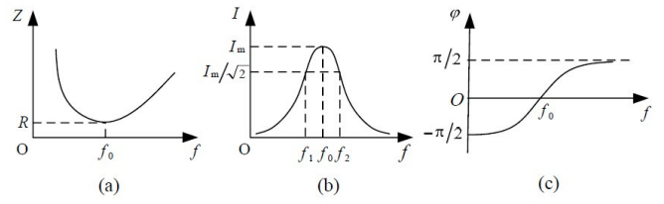 The generic shapes of the total impedance *Z*, the current *I*, and the phase difference $φ=φ_{u}-φ_{i}$ are shown in Figure 5, and we can find that they are all frequency dependent.

Figure 5. The impedance, the current and the phase difference as functions

of the frequency for a *RLC* series circuit (generic sketches).

According to Eqs. (8) and (9), $φ<0$ when the frequency is low ($f<f_{0}, i.e.1/ωC>ωL)$. The total voltage lags behind the current and the circuit is said to be *capacitive* in this case.

$φ=0$ when the circuit is resonant ($f=f_{0}, i.e. 1/ωC=ωL)$. Moreover, the voltages across the capacitor and the inductor should be equal. The circuit is said to be *resistive*.

$φ>0$ when the frequency is high ($f>f_{0}, i.e.1/ωC<ωL)$. The total voltage leads the current, and the circuit is said to be *inductive* in this case.

* + - 1. **Quality factor in resonant circuits**

Using $I_{m}=U/R$, we can calculate the voltages across the resistor, the inductor, and the capacitor as

$$U_{R}=I_{m}R=U,$$

$$U_{L}=I_{m}Z_{L}=\frac{U}{R}ωL,$$

$$U_{C}=I_{m}Z_{C}=\frac{U}{Rω_{0}C}=U_{L},$$

respectively. The ratio of $U_{L}$ (or $U_{C}$) to *U* is called the quality factor *Q* of a resonant circuit when the circuit is driven at the resonance frequency

$$Q=\frac{U_{L}}{U}=\frac{ω_{0}L}{R} or Q=\frac{U_{C}}{U}=\frac{1}{ω_{0}RC}.$$

If we fix the total voltage, the *Q* increases with the increase of $U_{L}$ and $U_{C}$. The value of *Q* can be used to quantify the efficiency of resonant circuits.

The quality factor can also be found as

$$Q=\frac{f_{0}}{f_{2}-f_{1}},$$

where $f_{1}$ and $f_{2}$ are two frequencies such that $I\left(f_{1}\right)=I\left(f_{2}\right)=I_{m}/\sqrt{2}$ (see Figure 5b).

1. **Apparatus [1]**
   1. **Experimental setup**

The measurement consists of an oscilloscope, a signal generator, a wiring board, a digital multimeter, a variable resistor 2 kΩ (2 W), a fixed resistor 100 Ω (2 W), two inductors (10 mH and 33 mH) and two capacitors (0.47 *µ*F and 0.1 *µ*F).

* 1. **Precision or uncertainty**

|  |  |  |  |
| --- | --- | --- | --- |
| *R* | 0.01 $Ω$ | $$T_{\frac{1}{2}}$$ | 0.001 $μ$ s / 0.01 $μ$ s |
| *C* | 0.01 nF / 0.1 nF | *L* | 0 |
| *f* | 0.001 Hz | $$U_{R}$$ | 0.02 $V_{pp}$/ 0.002 $V_{pp}$ |
| $$ε$$ | 0.001 $V_{pp}$ |

Table 1. Prescision or uncertainty

1. **Measurement procedure [1]**
   1. ***RC*, *RL* series circuit**
      1. First, we choose a capacitor and an inductor to assemble a circuit with the fixed-resistance 100 Ω resistor. Then, we adjust the output frequency of the square-wave signal provided by the signal generator. We also observe the change of the waveform when the time constant is smaller or greater than the period of the square–wave. We should choose the frequency that allows the capacitor to fully charge/discharge. Besides, we should use the **PRINT** function of the oscilloscope to store the waveforms.
      2. Then, we should adjust display parameters of the oscilloscope and measure $T_{1/2}$ for the studied circuits. And we should calculate the time constant and compare it with the theoretical value. We should keep in mind that in order to find the time constant accurately, only one period should be displayed on the oscilloscope screen.
   2. ***RLC* series circuit**
      1. First, we choose a capacitor and an inductor to assemble a *RLC* series circuit with the variable resistor. Then, we observe the waveform of the capacitor voltage in the underdamped, critically damped, and overdamped regimes. We should use the **PRINT** function of the oscilloscope to store the waveforms.
      2. Then, we should adjust the variable resistor to the critically damped regime. According to the definition of the half-life period $T_{1/2}$, we have *β $T_{1/2}$* = 1.68. By finding the value of $T_{1/2}$, the time constant can be found as *τ* = 1/*β* = $T_{1/2}$/1.68. We also need to compare the result with the theoretical value.
   3. ***RLC* resonant circuit**

We should apply a sinusoidal input voltage $U_{i}$ to the *RLC* series circuit, change the frequency, then observe the change of the voltage $U_{R}$ for a fixed resistor *R*, as well as the phase difference between $U_{R}$ and $U_{i}$. We then need to measure how $U_{R}$ changes with $U_{i}$ and calculate the phase difference according to Figure 4. After that, we should plot the graphs $I$/ $I_{m}$ vs. $f$/ $f_{0}$ and $φ$ vs. $f$/ $f_{0}$. Finally, we should estimate the resonance frequency and calculate the quality factor *Q*.

1. **Results**
   1. ***RC*, *RL* series circuit**
      1. ***RC* series circuit**

According to the procedure described in 3.1., we can get the table below (Table 2).

|  |  |
| --- | --- |
| Resistance *R* | 99.64 [$Ω$] $±$ 0.01 [$Ω$] |
| Frequency *f* | 5.000000 [kHz] $±$ 0.001 [Hz] |
| Voltage $ε$ | 4.000 [$V_{pp}$] $±$ 0.001 [$V_{pp}$] |
| Capacitance *C* | 101.21 [nF] $±$ 0.01 [nF] |
| Half-life period $T_{1/2}$ | 7.000 [$μ$ s] $±$ 0.001 [$μ$ s] |

Table 2. $T_{1/2}$ measurement data for a *RC* series circuit

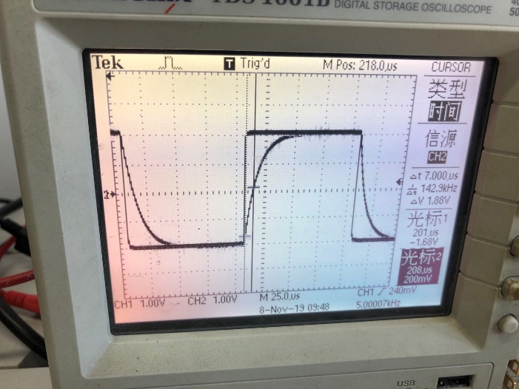And the figure below shows the waveform of *RC* series circuit to fully charge/discharge (Figure 6).

Figure 6. The waveform of *RC* series circuit to fully charge/discharge

Based on the experimental data of $T_{1/2}$, we can calculate the theoretical $τ$ as

$$τ_{experimental}=\frac{T_{1/2,experimental}}{\ln{2}}=1.00989×10^{-5}±1.4×{10}^{-9} [s].$$

And we can calculate the theoretical value for as

The relative error between them is

$$\frac{|τ_{theoretical}-τ_{experimental}|}{τ_{theoretical}}×100\%=0.15\%,$$

which is very small.

* + 1. ***RC* series circuit**

According to the procedure described in 3.1., we can get the table below (Table 3).

|  |  |
| --- | --- |
| Resistance *R* | 99.64 [$Ω$] $±$ 0.01 [$Ω$] |
| Frequency *f* | 1.000000 [kHz] $±$ 0.001 [Hz] |
| Voltage $ε$ | 4.000 [$V_{pp}$] $±$ 0.001 [$V_{pp}$] |
| Inductance *L* | 0.01 [H] $±$ 0 [H] |
| Half-life period $T_{1/2}$ | 80.00 [$μ$ s] $±$ 0.01 [$μ$ s] |

Table 3. $T_{1/2}$ measurement data for a *RL* series circuit

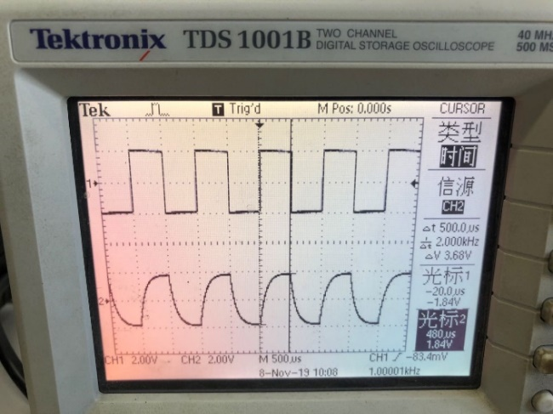And the figure below shows the waveform of *RL* series circuit to fully charge/discharge (Figure 7).

Figure 7. The waveform of *RL* series circuit to fully charge/discharge

Based on the experimental data of $T_{1/2}$, we can calculate the theoretical $τ$ as

$$τ_{experimental}=\frac{T_{1/2,experimental}}{\ln{2}}=1.154156×{10}^{-4}±1.4×{10}^{-9} [s].$$

And we can calculate the theoretical value for $τ$ as

$$τ_{theoretical}=\frac{L}{R}=\frac{0.01}{99.64}=1.004×{10}^{-4}±1.0×{10}^{-6} [s].$$

The relative error between them is

$$\frac{|τ_{theoretical}-τ_{experimental}|}{τ_{theoretical}}×100\%=15.0\%,$$

which is relatively large. We may think that this is mainly because of precision of the device. When using the **CURSOR** function, it increases or decreases 10s each time I adjust it. And I failed to make it more precise. If I can make the device be more precise, for example, increase or decrease 1s each time, the result will be better. Besides, we do not measure the actual inductance of the inductor and just use the value labeled on it, which will also contribute to the error. Besides, the inductor is also not ideal.

* 1. ***RLC* series circuit**

According to the procedure in 3.2., we can get the table below (Table 4).

|  |  |
| --- | --- |
| Inductance *L* | 0.01 [H] $±$ 0 [H] |
| Capacitance *C* | 101.21 [nF] $±$ 0.01 [nF] |
| Voltage $ε$ | 4.000 [$V_{pp}$] $±$ 0.001 [$V_{pp}$] |
| Frequency *f* | 100.000000 [kHz] $±$ 0.001 [Hz] |
| $$βt$$ | 1.68 |
| Half-life period $T_{1/2}$ | 120.00 [$μ$ s] $±$ 0.01 [$μ$ s] |

Table 4. $T_{1/2}$ measurement data for a critically damped *RLC* series circuit

Also, we recorded the figures for underdamped, critically damped and overdamped as shown below correspondingly (Figure 8).

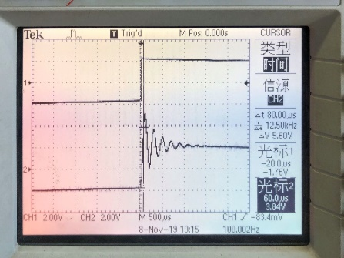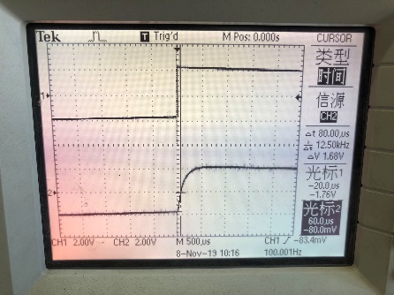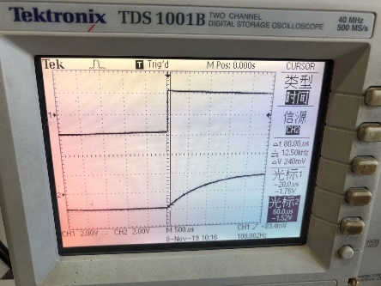Figure 8. Underdamped, critically damped and overdamped cases for *RLC* series circuit

Based on the experimental data of $T_{1/2}$, we can calculate the theoretical $τ$ as

$$τ_{experimental}=\frac{T_{1/2,experimental}}{1.68}=7.1429×{10}^{-5}±6×{10}^{-9} [s].$$

And we can calculate the theoretical value for $τ$ as

$$τ_{theoretical}=\sqrt{LC}=\sqrt{0.01×101.21×{10}^{-9}}=3.1814×{10}^{-5}±2×{10}^{-9} [s].$$

The relative error between them is

$$\frac{|τ_{theoretical}-τ_{experimental}|}{τ_{theoretical}}×100\%=125\%,$$

which is very large. There may be some wrong operations. For example, we should make the circuit to be critically damped, but this is very hard. The critically damped case only happens when , which is really difficult to make it, and we may miss it. Besides, the precision of the device may also increase the error. And we do not measure the actual inductance of the inductor and just use the value labeled on it, which will also contribute to the error. Moreover, the inductor is also not ideal. When using the **CURSOR** function, it increases or decreases 10s each time I adjust it. And I failed to make it more precise. If I can make the device be more precise, for example, increase or decrease 1s each time, the result will be better.

* 1. ***RLC* resonant circuit**

According to the procedure in 3.3., we can get the table below (Table 5).

|  |  |  |
| --- | --- | --- |
| *R* 99.64 [$Ω$] $±$ 0.01 [$Ω$], *L* 0.01 [H] $±$ 0 [H] | | |
| *C* 101.21 [nF] $±$ 0.01 [nF], $ε$ 4.000 [$V_{pp}$] $±$ 0.001 [$V_{pp}$] | | |
|  | $U_{R}$ [$V_{pp}$] $±$ 0.02/0.002 [$V_{pp}$] | *f* [kHz] $±$ 0.001 [Hz] |
| 1 | 0.304 | 1.000000 |
| 2 | 0.648 | 2.000000 |
| 3 | 1.15 | 3.000000 |
| 4 | 1.74 | 4.000000 |
| 5 | 3.80 | 5.000000 |
| 6 | 2.60 | 6.000000 |
| 7 | 1.68 | 7.000000 |
| 8 | 1.28 | 8.000000 |
| 9 | 1.04 | 9.000000 |
| 10 | 0.880 | 10.000000 |
| 11 | 0.760 | 11.000000 |
| 12 | 0.680 | 12.000000 |
| 13 | 0.640 | 13.000000 |
| 14 | 0.560 | 14.000000 |
| 15 | 0.520 | 15.000000 |
| 16 | 0.480 | 16.000000 |
| 17 | 0.440 | 17.000000 |
| 18 | 0.420 | 18.000000 |
| 19 | 0.392 | 19.000000 |
| 20 | 0.340 | 20.000000 |
| 21 | 0.320 | 21.000000 |
| 22 | 3.24 | 4.500000 |
| 23 | 2.68 | 4.200000 |
| 24 | 3.68 | 4.800000 |
| 25 | 3.64 | 5.300000 |
| 26 | 3.32 | 5.500000 |

Table 5. Measurement data for the $U_{R}$ vs. *f* dependence for a *RLC* resonant circuit

From this table, we can get that

$$U_{m}=3.80 \left[V_{pp}\right]±0.02 \left[V_{pp}\right]$$

$$f_{0}=5.000000 \left[kHz\right]±0.001 [Hz]$$

In order to get $I/I_{m}$, we can calculate $U/U_{m}$ according to Ohm’s law. Taking the first data as an example

$$\frac{I}{I_{m}}=\frac{U}{U_{m}}=\frac{0.304}{3.80}=0.0800±0.0007$$

$$\frac{f}{f_{0}}=\frac{1000.000}{5000.000}=0.2000000±0.0000002$$

Then, we can get the following table (Table 6).

|  |  |  |  |  |
| --- | --- | --- | --- | --- |
|  | $$\frac{I}{I_{m}}$$ | Uncertainty | $$\frac{f}{f_{0}}$$ | Uncertainty |
| 1 | 0.0800 | 0.0007 | 0.2000000 | 0.0000002 |
| 2 | 0.1705 | 0.0010 | 0.4000000 | 0.0000002 |
| 3 | 0.303 | 0.005 | 0.6000000 | 0.0000002 |
| 4 | 0.458 | 0.006 | 0.8000000 | 0.0000003 |
| 5 | 1.000 | 0.007 | 1.0000000 | 0.0000003 |
| 6 | 0.684 | 0.006 | 1.2000000 | 0.0000003 |
| 7 | 0.442 | 0.006 | 1.4000000 | 0.0000003 |
| 8 | 0.337 | 0.006 | 1.6000000 | 0.0000004 |
| 9 | 0.274 | 0.005 | 1.8000000 | 0.0000004 |
| 10 | 0.2316 | 0.0013 | 2.0000000 | 0.0000004 |
| 11 | 0.2000 | 0.0012 | 2.2000000 | 0.0000005 |
| 12 | 0.1789 | 0.0011 | 2.4000000 | 0.0000005 |
| 13 | 0.1684 | 0.0010 | 2.6000000 | 0.0000006 |
| 14 | 0.1474 | 0.0009 | 2.8000000 | 0.0000006 |
| 15 | 0.1368 | 0.0009 | 3.0000000 | 0.0000006 |
| 16 | 0.1263 | 0.0008 | 3.2000000 | 0.0000007 |
| 17 | 0.1158 | 0.0008 | 3.4000000 | 0.0000007 |
| 18 | 0.1105 | 0.0008 | 3.6000000 | 0.0000007 |
| 19 | 0.1032 | 0.0008 | 3.8000000 | 0.0000008 |
| 20 | 0.0895 | 0.0007 | 4.0000000 | 0.0000008 |
| 21 | 0.0842 | 0.0007 | 4.2000000 | 0.0000009 |
| 22 | 0.853 | 0.007 | 0.9000000 | 0.0000003 |
| 23 | 0.705 | 0.006 | 0.8400000 | 0.0000003 |
| 24 | 0.968 | 0.007 | 0.9600000 | 0.0000003 |
| 25 | 0.958 | 0.007 | 1.0600000 | 0.0000003 |
| 26 | 0.874 | 0.007 | 1.1000000 | 0.0000003 |

Table 6. Calculated value and uncertainty for $\frac{I}{I_{m}}$ and $\frac{f}{f_{0}}$

With these data, we can get the figure below (Figure 9).

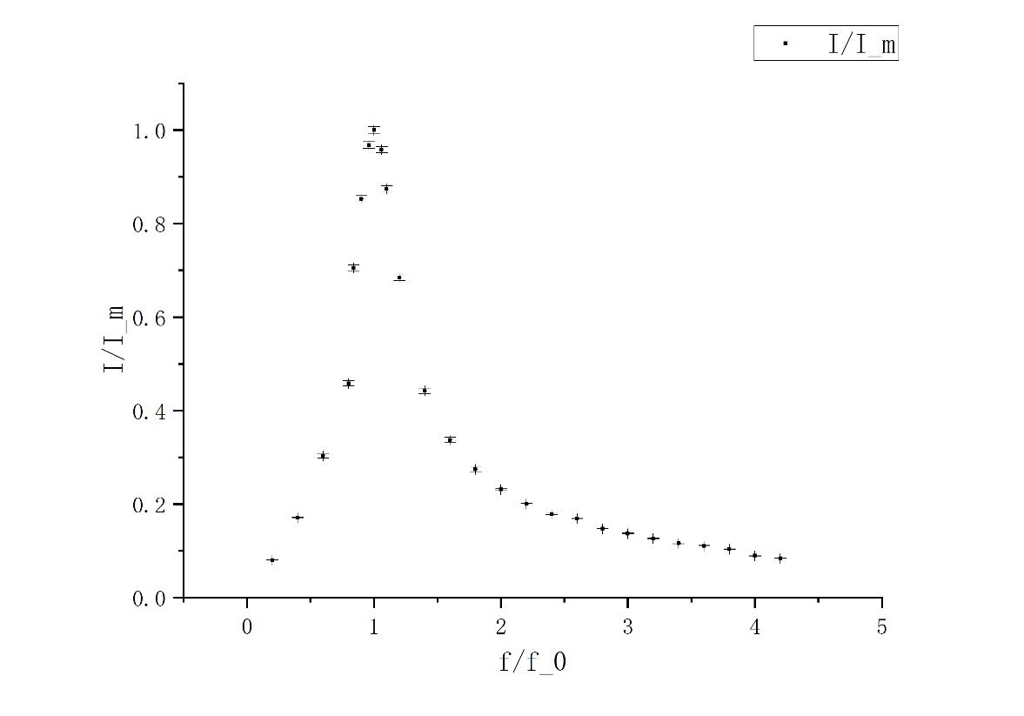Figure 9. $\frac{I}{I_{m}}$ vs. $\frac{f}{f_{0}}$

From this figure, we can find that $\frac{I}{I_{m}}$ first increases for $\frac{f}{f_{0}}<1$. And the increasing speed becomes larger when $\frac{f}{f_{0}}$ is closer to 1. Then $\frac{I}{I_{m}}$ reaches a peak at $\frac{f}{f_{0}}=1$. Finally, $\frac{I}{I_{m}}$ decreases for $\frac{f}{f_{0}}>1$, and the speed for decreasing becomes slower with the increase of $\frac{f}{f_{0}}$.

For phase difference, using the first measurement, we can calculate it as:

$$φ_{experimental}=\cos^{-1}{\frac{U_{R}}{U_{m}}}=\cos^{-1}{\frac{0.304}{3.80}}=1.4907±0.0007 [rad]$$

And we can add the minus sign on $φ_{experimental}$ when $\frac{f}{f_{0}}<1$. Then, the whole table is listed below (Table 7)

|  |  |  |  |  |
| --- | --- | --- | --- | --- |
|  | $φ_{experimental}$ [rad] | Uncertainty  [rad] | $$\frac{f}{f_{0}}$$ | Uncertainty |
| 1 | -1.4907 | 0.0007 | 0.2000000 | 0.0000002 |
| 2 | -1.3994 | 0.0011 | 0.4000000 | 0.0000002 |
| 3 | -1.263 | 0.006 | 0.6000000 | 0.0000002 |
| 4 | -1.095 | 0.007 | 0.8000000 | 0.0000003 |
| 5 | 0.000 | 0.000 | 1.0000000 | 0.0000003 |
| 6 | 0.817 | 0.009 | 1.2000000 | 0.0000003 |
| 7 | 1.113 | 0.006 | 1.4000000 | 0.0000003 |
| 8 | 1.227 | 0.006 | 1.6000000 | 0.0000004 |
| 9 | 1.294 | 0.006 | 1.8000000 | 0.0000004 |
| 10 | 1.3371 | 0.0014 | 2.0000000 | 0.0000004 |
| 11 | 1.3694 | 0.0012 | 2.2000000 | 0.0000005 |
| 12 | 1.3909 | 0.0011 | 2.4000000 | 0.0000005 |
| 13 | 1.4016 | 0.0010 | 2.6000000 | 0.0000006 |
| 14 | 1.4229 | 0.0009 | 2.8000000 | 0.0000006 |
| 15 | 1.4335 | 0.0009 | 3.0000000 | 0.0000006 |
| 16 | 1.4441 | 0.0009 | 3.2000000 | 0.0000007 |
| 17 | 1.4547 | 0.0008 | 3.4000000 | 0.0000007 |
| 18 | 1.4600 | 0.0008 | 3.6000000 | 0.0000007 |
| 19 | 1.4675 | 0.0008 | 3.8000000 | 0.0000008 |
| 20 | 1.4812 | 0.0007 | 4.0000000 | 0.0000008 |
| 21 | 1.4865 | 0.0007 | 4.2000000 | 0.0000009 |
| 22 | -0.55 | 0.01 | 0.9000000 | 0.0000003 |
| 23 | -0.788 | 0.009 | 0.8400000 | 0.0000003 |
| 24 | -0.25 | 0.03 | 0.9600000 | 0.0000003 |
| 25 | 0.29 | 0.03 | 1.0600000 | 0.0000003 |
| 26 | 0.508 | 0.014 | 1.1000000 | 0.0000003 |

Table 7. Calculated value and uncertainty for $φ_{experimental}$ and $\frac{f}{f_{0}}$

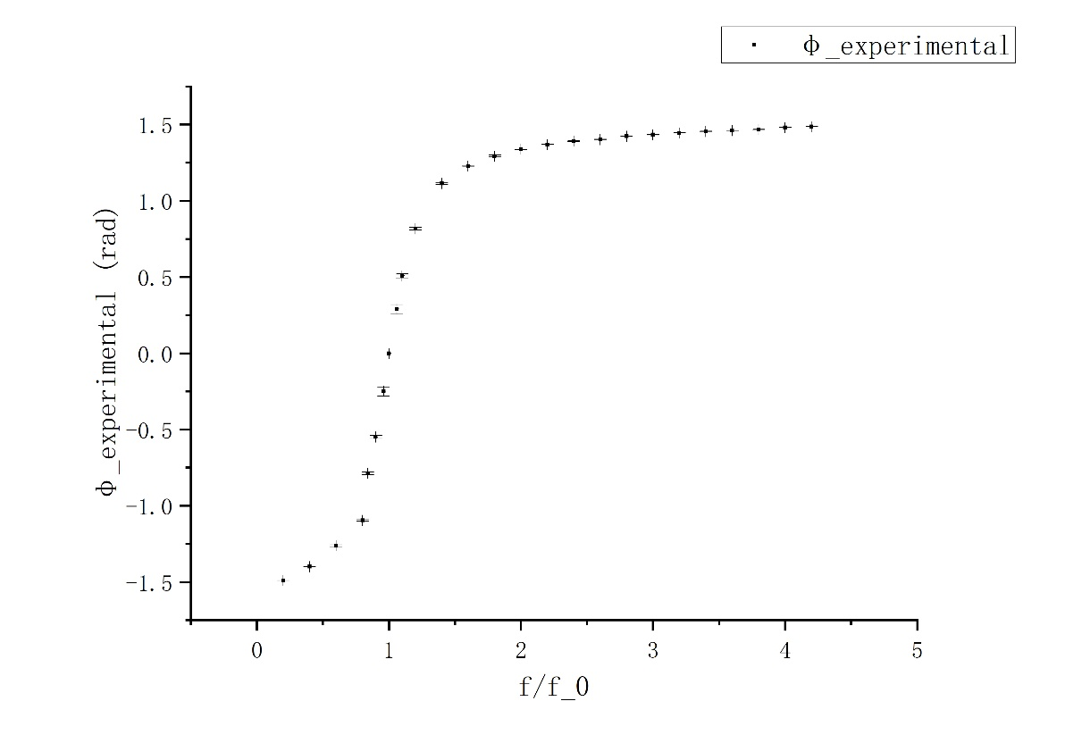With these data, we can get the figure below (Figure 10).

Figure 10. $φ_{experimental}$ vs. $\frac{f}{f_{0}}$

From this figure, we can find that the phase difference changes rapidly near $\frac{f}{f_{0}}=1$ while the speed of changing slows down when $\frac{f}{f_{0}}$ is away from 1.

To calculate the theoretical phase difference, we also use the first measurement as an example:

$$φ_{theoretical}=\tan^{-1}\left(\frac{2πfL-\frac{1}{2πfC}}{R}\right)=\tan^{-1}\left(\frac{2π×1000.000×0.01-\frac{1}{2π×1000.0000×101.21×{10}^{-9}}}{99.64}\right)=-1.504892±0.000009 [rad]$$

The whole table is listed below (Table 8).

|  |  |  |  |  |
| --- | --- | --- | --- | --- |
|  | $φ_{theoretical}$ [rad] | Uncertainty  [rad] | $$\frac{f}{f_{0}}$$ | Uncertainty |
| 1 | -1.504892 | 0.000009 | 0.2000000 | 0.0000002 |
| 2 | -1.42109 | 0.00002 | 0.4000000 | 0.0000002 |
| 3 | -1.28225 | 0.00005 | 0.6000000 | 0.0000002 |
| 4 | -0.95828 | 0.00014 | 0.8000000 | 0.0000003 |
| 5 | -0.0035 | 0.0003 | 1.0000000 | 0.0000003 |
| 6 | 0.85643 | 0.00012 | 1.2000000 | 0.0000003 |
| 7 | 1.13713 | 0.00005 | 1.4000000 | 0.0000003 |
| 8 | 1.25609 | 0.00003 | 1.6000000 | 0.0000004 |
| 9 | 1.32113 | 0.00003 | 1.8000000 | 0.0000004 |
| 10 | 1.36235 | 0.00002 | 2.0000000 | 0.0000004 |
| 11 | 1.39100 | 0.00002 | 2.2000000 | 0.0000005 |
| 12 | 1.41219 | 0.00002 | 2.4000000 | 0.0000005 |
| 13 | 1.428572 | 0.000014 | 2.6000000 | 0.0000006 |
| 14 | 1.441665 | 0.000013 | 2.8000000 | 0.0000006 |
| 15 | 1.452400 | 0.000012 | 3.0000000 | 0.0000006 |
| 16 | 1.461382 | 0.000011 | 3.2000000 | 0.0000007 |
| 17 | 1.469021 | 0.000010 | 3.4000000 | 0.0000007 |
| 18 | 1.475609 | 0.000010 | 3.6000000 | 0.0000007 |
| 19 | 1.481354 | 0.000009 | 3.8000000 | 0.0000008 |
| 20 | 1.486414 | 0.000008 | 4.0000000 | 0.0000008 |
| 21 | 1.490908 | 0.000008 | 4.2000000 | 0.0000009 |
| 22 | -0.5899 | 0.0002 | 0.9000000 | 0.0000003 |
| 23 | -0.8371 | 0.0002 | 0.8400000 | 0.0000003 |
| 24 | -0.2554 | 0.0003 | 0.9600000 | 0.0000003 |
| 25 | 0.3494 | 0.0003 | 1.0600000 | 0.0000003 |
| 26 | 0.5395 | 0.0002 | 1.1000000 | 0.0000003 |

Table 7. Calculated value and uncertainty for $φ_{theoretical}$ and $\frac{f}{f_{0}}$

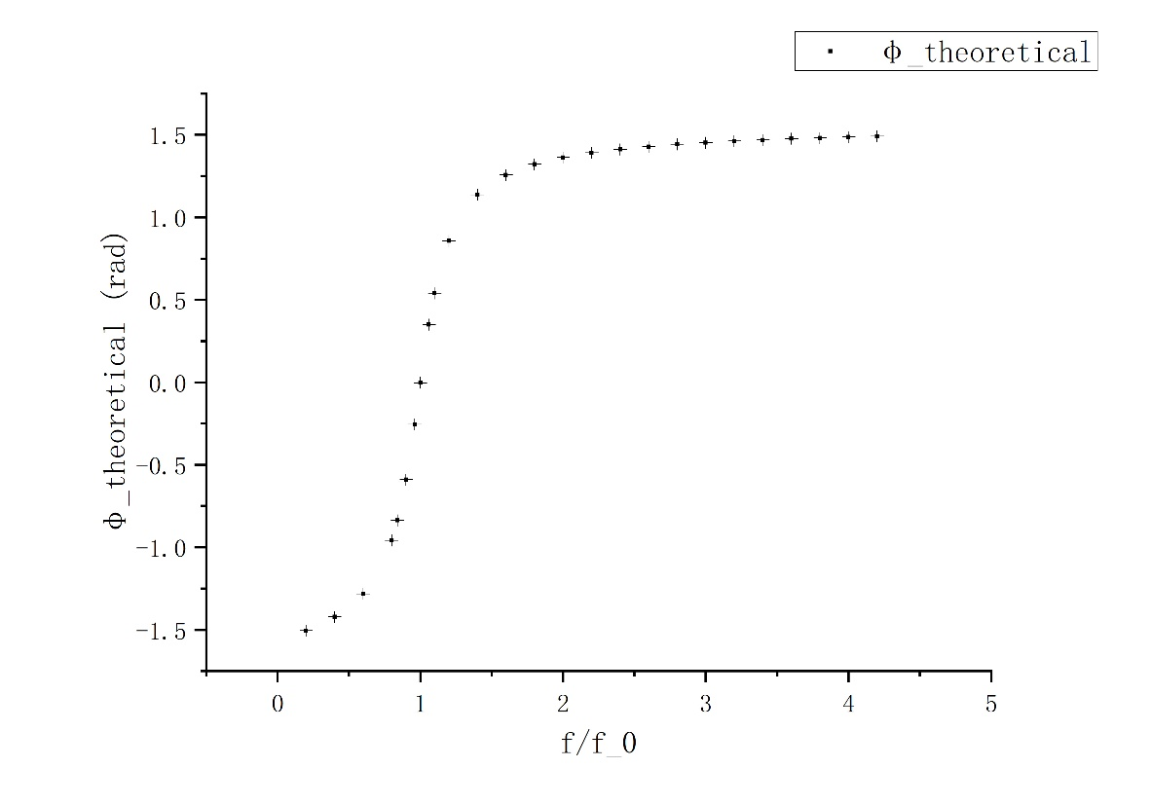With these data, we can get the figure below (Figure 11).

Figure 11. $φ_{theoretical}$ vs. $\frac{f}{f_{0}}$

Compared with the experimental one, we can find that they have the same shape.

The theoretical resonant frequency can be calculated as

$$f_{theoretical}=\frac{1}{2π\sqrt{LC}}=\frac{1}{2π\sqrt{0.01×101.21×{10}^{-9}}}=5002.7±0.2 \left[Hz\right],$$

and the relative error is calculated as

$$\frac{|5002.7-5000.000|}{5002.7}×100\%=0.06\%,$$

which is very small, and we can assume this part is very successful.

Then, we calculate the quality factor. For the theoretical one,

$$Q_{theoretical}=\frac{\sqrt{LC}}{RC}=\frac{\sqrt{0.01×101.21×{10}^{-9}}}{99.64×101.21×{10}^{-9}}=3.1547±0.0004$$

For the experimental one,

$$I\left(f_{1}\right)=I\left(f_{2}\right)=\frac{I_{m}}{\sqrt{2}},$$

then, $f_{1}≈4200.000±0.001 \left[Hz\right], f_{2}≈6000.000±0.001 \left[Hz\right]$

$$Q_{experimental}=\frac{f_{0}}{f_{2}-f_{1}}=\frac{5000.000}{6000.000-4200.000}=2.777778±0.000002,$$

and the relative error can be calculated as

$$\frac{|3.1547-2.777778|}{3.1547}×100\%=11.95\%,$$

which is relatively large. We may think the reasons for it are that first $f_{1}$ and $f_{2}$ are found by estimation, which will contribute to the error. Second, the interval between each frequency is large, which prevents us from a more accurate estimation. Third, the points I chose have not covered form an ideal shape in the graph, for example, when $\frac{f}{f_{0}}<1$, the dots I have are not enough, which make the graph ends abruptly.

1. **Conclusion [1]**
   1. ***RC*, *RL* series circuit**

For *RC* series circuit, we have

$$τ_{experimental}=\frac{T_{1/2,experimental}}{\ln{2}}=1.00989×10^{-5}±1.4×{10}^{-9} [s].$$

$$τ_{theoretical}=RC=99.64×101.21×{10}^{-9}=1.00846×10^{-5}±1.4×{10}^{-9}\left[s\right].$$

$$\frac{|τ_{theoretical}-τ_{experimental}|}{τ_{theoretical}}×100\%=0.15\%,$$

which is quite successful.

For *RL* series circuit, we have

$$τ_{experimental}=\frac{T_{1/2,experimental}}{\ln{2}}=1.154156×{10}^{-4}±1.4×{10}^{-9} [s].$$

$$τ_{theoretical}=\frac{L}{R}=\frac{0.01}{99.64}=1.004×{10}^{-4}±1.0×{10}^{-6} [s].$$

$$\frac{|τ_{theoretical}-τ_{experimental}|}{τ_{theoretical}}×100\%=15.0\%,$$

which is relatively large. We may think that this is mainly because of precision of the device. When using the **CURSOR** function, it increases or decreases 10s each time I adjust it. And I failed to make it more precise. If I can make the device be more precise, for example, increase or decrease 1s each time, the result will be better. Besides, we do not measure the actual inductance of the inductor and just use the value labeled on it, which will also contribute to the error. Besides, the inductor is also not ideal.

* 1. ***RLC* Series Circuit**

For *RLC* series circuit, we have

$$τ_{experimental}=\frac{T_{1/2,experimental}}{1.68}=7.1429×{10}^{-5}±6×{10}^{-9} [s].$$

$$τ_{theoretical}=\sqrt{LC}=\sqrt{0.01×101.21×{10}^{-9}}=3.1814×{10}^{-5}±2×{10}^{-9} [s].$$

$$\frac{|τ_{theoretical}-τ_{experimental}|}{τ_{theoretical}}×100\%=125\%,$$

which is very large. There may be some wrong operations. For example, we should make the circuit to be critically damped, but this is very hard. The critically damped case only happens when , which is really difficult to make it, and we may miss it. Besides, the precision of the device may also increase the error. And we do not measure the actual inductance of the inductor and just use the value labeled on it, which will also contribute to the error. Moreover, the inductor is also not ideal. When using the **CURSOR** function, it increases or decreases 10s each time I adjust it. And I failed to make it more precise. If I can make the device be more precise, for example, increase or decrease 1s each time, the result will be better.

* 1. ***RLC* Resonant Circuit**

In this part, we first have and observe the graph for $\frac{I}{I_{m}}$ vs. $\frac{f}{f_{0}}$, and find that $\frac{I}{I_{m}}$ first increases for $\frac{f}{f_{0}}<1$. And the increasing speed becomes larger when $\frac{f}{f_{0}}$ is closer to 1. Then $\frac{I}{I_{m}}$ reaches a peak at $\frac{f}{f_{0}}=1$. Finally, $\frac{I}{I_{m}}$ decreases for $\frac{f}{f_{0}}>1$, and the speed for decreasing becomes slower with the increase of $\frac{f}{f_{0}}$.

Then, we calculate $φ_{theoretical}$ and $φ_{experimental}$, and compare their $\frac{f}{f_{0}}$-dependent figures. We find that they have the same shape, so we may think this part is successful.

Then, we calculate theoretical resonant frequency as

$$f_{theoretical}=\frac{1}{2π\sqrt{LC}}=\frac{1}{2π\sqrt{0.01×101.21×{10}^{-9}}}=5002.7±0.2 \left[Hz\right],$$

and compare it with the experimental one, and the relative error is $0.06\%$, which is also quite successful.

Finally, we calculate quality factor theoretically and experimentally, $$Q_{theoretical}=\frac{\sqrt{LC}}{RC}=\frac{\sqrt{0.01×101.21×{10}^{-9}}}{99.64×101.21×{10}^{-9}}=3.1547±0.0004$$

$$Q_{experimental}=\frac{f_{0}}{f_{2}-f_{1}}=\frac{5000.000}{6000.000-4200.000}=2.777778±0.000002.$$

The relative error is $11.95\%,$ which is relatively large. We may think the reasons for it are that first $f_{1}$ and $f_{2}$ are found by estimation, which will contribute to the error. Second, the interval between each frequency is large, which prevents us from a more accurate estimation. Third, the points I chose have not covered form an ideal shape in the graph, for example, when $\frac{f}{f_{0}}<1$, the dots I have are not enough, which make the graph ends abruptly.

1. **References**

[1] Exercise 5 - lab manual [rev 2.6], UM-JI SJTU. Edited by Qin Tian, Feng Yaming, Gu Yichen, Mateusz Krzyzosiak.

[2] Uncertainty analysis handbook, UM-JI SJTU.

1. **Uncertainty analysis [2]**

**A.1. Uncertainty for *RC, RL* series circuit**

For both *RC* and *RL* series circuit, since $T_{1/2}$ is measured directly, there is only type-B uncertainty:

$$u_{T_{1/2}}=u_{B}=0.001 [μs]$$

Then, we can calculate the uncertainty for experimental $τ$ as:

$$u_{τ_{experimental}}=\frac{u_{T_{1/2}}}{\ln{2}}=\frac{0.001×{10}^{-6}}{\ln{2}}=1.4×{10}^{-9} [s]$$

In *RC* series circuit, $τ=RC$. Besides, *R* and *C* are measured directly, they only have type-B uncertainty:

$$u_{R}=u_{B}=0.01 [Ω]$$

$$u_{C}=u_{B}=0.01×{10}^{-9}=1×{10}^{-11} [F]$$

Then, we can calculate the uncertainty for theoretical $τ$

$$u_{τ_{theoretical}}=\sqrt{{\left(\frac{∂RC}{∂R}u_{R}\right)}^{2}+{\left(\frac{∂RC}{∂C}u_{C}\right)}^{2}}=\sqrt{{\left(Cu_{R}\right)}^{2}+{\left(Ru_{C}\right)}^{2}}=\sqrt{{\left(101.21×{10}^{-9}×0.01\right)}^{2}+{\left(99.64×1×{10}^{-11}\right)}^{2}}=1.4×{10}^{-9} [s]$$

In *RL* series circuit, $τ=\frac{L}{R}$. Besides, *R* is measured directly, so it only has type-B uncertainty, and we assume the uncertainty for *L* is 0:

$$u_{R}=u_{B}=0.01 [Ω]$$

$$u_{L}=0 [H]$$

Then, we can calculate the uncertainty for theoretical $τ$

$$u_{τ_{theoretical}}=\sqrt{{\left(\frac{∂\frac{L}{R}}{∂R}u_{R}\right)}^{2}+{\left(\frac{∂\frac{L}{R}}{∂L}u_{L}\right)}^{2}}=\sqrt{{\left(\frac{Lu_{R}}{R^{2}}\right)}^{2}}=\sqrt{{\left(\frac{0.01×0.01}{{99.64}^{2}}\right)}^{2}}=1.0×{10}^{-6} [s]$$

**A.2. Uncertainty for *RLC* series circuit**

For *RLC* series circuit, since $T_{1/2}$ is measured directly, there is only type-B uncertainty:

$$u_{T_{1/2}}=u_{B}=0.01 [μs]$$

Then, we can calculate the uncertainty for experimental $τ$ as:

$$u_{τ_{experimental}}=\frac{u_{T_{1/2}}}{1.68}=\frac{0.01×{10}^{-6}}{1.68}=6×{10}^{-9} [s]$$

In *RLC* series circuit, $τ=\sqrt{LC}$. Besides, *C* is measured directly, so it only has type-B uncertainty, and we assume the uncertainty for *L* is 0:

$$u_{C}=u_{C}=0.01×{10}^{-9}=1×{10}^{-11} [F]$$

$$u_{L}=0 [H]$$

Then, we can calculate the uncertainty for theoretical $τ$

$$u_{τ_{theoretical}}=\sqrt{{\left(\frac{∂\sqrt{LC}}{∂C}u_{C}\right)}^{2}+{\left(\frac{∂\sqrt{LC}}{∂L}u_{L}\right)}^{2}}=\sqrt{{\left(\frac{u_{C}\sqrt{L}}{2\sqrt{C}}\right)}^{2}}$$

$$=\sqrt{{\left(\frac{1×{10}^{-11}×\sqrt{0.01}}{2\sqrt{101.21×{10}^{-9}}}\right)}^{2}}=2×{10}^{-9} [s]$$

**A.2. Uncertainty for *RLC* resonant circuit**

Since $I, I_{m}, f and f_{0}$ are measured directly, they only have type-B uncertainty. Besides, $$\frac{I}{I_{m}}=\frac{U}{U_{m}},$$

therefore, $$u_{\frac{I}{I_{m}}}=u_{\frac{U}{U_{m}}}.$$

Then we can get below using the first measurement as an example:

$$u_{\frac{I}{I_{m}}}=u_{\frac{U}{U_{m}}}=\sqrt{{\left(\frac{∂\frac{U}{U_{m}}}{∂U}×u_{U}\right)}^{2}+{\left(\frac{∂\frac{U}{U_{m}}}{∂U_{m}}×u_{U_{m}}\right)}^{2}}=\sqrt{{\left(\frac{u_{U}}{U_{m}}\right)}^{2}+{\left(\frac{Uu_{U_{m}}}{U_{m}^{2}}\right)}^{2}}=\sqrt{{\left(\frac{0.002}{3.80}\right)}^{2}+{\left(\frac{0.304×0.02}{{3.80}^{2}}\right)}^{2}}=0.0007$$

$$u_{\frac{f}{f_{0}}}=\sqrt{{\left(\frac{∂\frac{f}{f_{0}}}{∂f}×u_{f}\right)}^{2}+{\left(\frac{∂\frac{f}{f_{0}}}{∂f_{0}}×u_{f_{0}}\right)}^{2}}=\sqrt{{\left(\frac{u_{f}}{f_{0}}\right)}^{2}+{\left(\frac{fu_{f_{0}}}{f_{0}^{2}}\right)}^{2}}=\sqrt{{\left(\frac{0.001}{5000}\right)}^{2}+{\left(\frac{1000×0.001}{{5000}^{2}}\right)}^{2}}=0.0000002$$

The whole table for uncertainty is listed below (Table 8).

|  |  |  |  |  |
| --- | --- | --- | --- | --- |
|  | $$\frac{I}{I_{m}}$$ | Uncertainty | $$\frac{f}{f_{0}}$$ | Uncertainty |
| 1 | 0.0800 | 0.0007 | 0.2000000 | 0.0000002 |
| 2 | 0.1705 | 0.0010 | 0.4000000 | 0.0000002 |
| 3 | 0.303 | 0.005 | 0.6000000 | 0.0000002 |
| 4 | 0.458 | 0.006 | 0.8000000 | 0.0000003 |
| 5 | 1.000 | 0.007 | 1.0000000 | 0.0000003 |
| 6 | 0.684 | 0.006 | 1.2000000 | 0.0000003 |
| 7 | 0.442 | 0.006 | 1.4000000 | 0.0000003 |
| 8 | 0.337 | 0.006 | 1.6000000 | 0.0000004 |
| 9 | 0.274 | 0.005 | 1.8000000 | 0.0000004 |
| 10 | 0.2316 | 0.0013 | 2.0000000 | 0.0000004 |
| 11 | 0.2000 | 0.0012 | 2.2000000 | 0.0000005 |
| 12 | 0.1789 | 0.0011 | 2.4000000 | 0.0000005 |
| 13 | 0.1684 | 0.0010 | 2.6000000 | 0.0000006 |
| 14 | 0.1474 | 0.0009 | 2.8000000 | 0.0000006 |
| 15 | 0.1368 | 0.0009 | 3.0000000 | 0.0000006 |
| 16 | 0.1263 | 0.0008 | 3.2000000 | 0.0000007 |
| 17 | 0.1158 | 0.0008 | 3.4000000 | 0.0000007 |
| 18 | 0.1105 | 0.0008 | 3.6000000 | 0.0000007 |
| 19 | 0.1032 | 0.0008 | 3.8000000 | 0.0000008 |
| 20 | 0.0895 | 0.0007 | 4.0000000 | 0.0000008 |
| 21 | 0.0842 | 0.0007 | 4.2000000 | 0.0000009 |
| 22 | 0.853 | 0.007 | 0.9000000 | 0.0000003 |
| 23 | 0.705 | 0.006 | 0.8400000 | 0.0000003 |
| 24 | 0.968 | 0.007 | 0.9600000 | 0.0000003 |
| 25 | 0.958 | 0.007 | 1.0600000 | 0.0000003 |
| 26 | 0.874 | 0.007 | 1.1000000 | 0.0000003 |

Table 8. Calculated value and uncertainty for $\frac{I}{I_{m}}$ and $\frac{f}{f_{0}}$

To calculate the uncertainty for $φ=\cos^{-1}{\frac{U_{R}}{U_{m}}}$, using the first measurement as an example:

$$u_{φ}=\sqrt{{\left(\frac{∂φ}{∂U_{R}}u_{U_{R}}\right)}^{2}+{\left(\frac{∂φ}{∂U_{m}}u_{U_{m}}\right)}^{2}}=\sqrt{{\left(\frac{u_{U_{R}}}{U_{m}\sqrt{1-{\left(\frac{U_{R}}{U_{m}}\right)}^{2}}}\right)}^{2}+{\left(\frac{U_{R}u_{U_{m}}}{U_{m}^{2}\sqrt{1-{\left(\frac{U_{R}}{U_{m}}\right)}^{2}}}\right)}^{2}}$$

$$=\sqrt{{\left(\frac{0.002}{3.80×\sqrt{1-{\left(\frac{0.304}{3.80}\right)}^{2}}}\right)}^{2}+{\left(\frac{0.304×0.02}{{3.80}^{2}×\sqrt{1-{\left(\frac{0.304}{3.80}\right)}^{2}}}\right)}^{2}}=0.0007 [rad]$$

The whole table for uncertainty is listed below (Table 9).

|  |  |  |  |  |
| --- | --- | --- | --- | --- |
|  | $φ_{experimental}$ [rad] | Uncertainty  [rad] | $$\frac{f}{f_{0}}$$ | Uncertainty |
| 1 | -1.4907 | 0.0007 | 0.2000000 | 0.0000002 |
| 2 | -1.3994 | 0.0011 | 0.4000000 | 0.0000002 |
| 3 | -1.263 | 0.006 | 0.6000000 | 0.0000002 |
| 4 | -1.095 | 0.007 | 0.8000000 | 0.0000003 |
| 5 | 0.000 | 0.000 | 1.0000000 | 0.0000003 |
| 6 | 0.817 | 0.009 | 1.2000000 | 0.0000003 |
| 7 | 1.113 | 0.006 | 1.4000000 | 0.0000003 |
| 8 | 1.227 | 0.006 | 1.6000000 | 0.0000004 |
| 9 | 1.294 | 0.006 | 1.8000000 | 0.0000004 |
| 10 | 1.3371 | 0.0014 | 2.0000000 | 0.0000004 |
| 11 | 1.3694 | 0.0012 | 2.2000000 | 0.0000005 |
| 12 | 1.3909 | 0.0011 | 2.4000000 | 0.0000005 |
| 13 | 1.4016 | 0.0010 | 2.6000000 | 0.0000006 |
| 14 | 1.4229 | 0.0009 | 2.8000000 | 0.0000006 |
| 15 | 1.4335 | 0.0009 | 3.0000000 | 0.0000006 |
| 16 | 1.4441 | 0.0009 | 3.2000000 | 0.0000007 |
| 17 | 1.4547 | 0.0008 | 3.4000000 | 0.0000007 |
| 18 | 1.4600 | 0.0008 | 3.6000000 | 0.0000007 |
| 19 | 1.4675 | 0.0008 | 3.8000000 | 0.0000008 |
| 20 | 1.4812 | 0.0007 | 4.0000000 | 0.0000008 |
| 21 | 1.4865 | 0.0007 | 4.2000000 | 0.0000009 |
| 22 | -0.55 | 0.01 | 0.9000000 | 0.0000003 |
| 23 | -0.788 | 0.009 | 0.8400000 | 0.0000003 |
| 24 | -0.25 | 0.03 | 0.9600000 | 0.0000003 |
| 25 | 0.29 | 0.03 | 1.0600000 | 0.0000003 |
| 26 | 0.508 | 0.014 | 1.1000000 | 0.0000003 |

Table 9. Calculated value and uncertainty for $φ_{experimental}$ and $\frac{f}{f_{0}}$

To calculate the uncertainty for $φ=\tan^{-1}\left(\frac{2πfL-\frac{1}{2πfC}}{R}\right)$, using the first measurement as an example:

$$u_{φ}=\sqrt{{\left(\frac{∂φ}{∂f}u_{f}\right)}^{2}+{\left(\frac{∂φ}{∂C}u_{C}\right)}^{2}+{\left(\frac{∂φ}{∂R}u_{R}\right)}^{2}} =\sqrt{{\left(\frac{u_{f}R\left(2πL+\frac{1}{2πf^{2}C}\right)}{R^{2}+{\left(2πfL-\frac{1}{2πfC}\right)}^{2}}\right)}^{2}+{\left(\frac{u_{C}R×\frac{1}{2πfC^{2}}}{R^{2}+{\left(2πfL-\frac{1}{2πfC}\right)}^{2}}\right)}^{2}+{\left(\frac{u_{R}\left(\frac{1}{2πfC}-2πfL\right)}{R^{2}+{\left(2πfL-\frac{1}{2πfC}\right)}^{2}}\right)}^{2}}$$

$$\frac{u_{f}R\left(2πL+\frac{1}{2πf^{2}C}\right)}{R^{2}+{\left(2πfL-\frac{1}{2πfC}\right)}^{2}}=\frac{0.001×99.64×\left(2π×0.01+\frac{1}{2π{×1000}^{2}×101.21×{10}^{-9}}\right)}{{99.64}^{2}+{\left(2π×1000×0.01-\frac{1}{2π×1000×101.21×{10}^{-9}}\right)}^{2}}$$

$$=7.12×10^{-8}$$

$$\frac{u_{C}R×\frac{1}{2πfC^{2}}}{R^{2}+{\left(2πfL-\frac{1}{2πfC}\right)}^{2}}=\frac{0.01×{10}^{-9}×99.64×\frac{1}{2π×1000×{\left(101.21×{10}^{-9}\right)}^{2}}}{99.64^{2}+{\left(2π×1000×0.01-\frac{1}{2π×1000×101.21×10^{-9}}\right)}^{2}}$$

$$=6.76×10^{-6}$$

$$\frac{u_{R}\left(\frac{1}{2πfC}-2πfL\right)}{R^{2}+{\left(2πfL-\frac{1}{2πfC}\right)}^{2}}=\frac{0.01×\left(\frac{1}{2π×1000×101.21×10^{-9}}-2π×1000×0.01\right)}{99.64^{2}+{\left(2π×1000×0.01-\frac{1}{2π×1000×101.21×10^{-9}}\right)}^{2}}$$

$$=6.60×10^{-6}$$

$$u_{φ}=\sqrt{{\left(7.12×10^{-8}\right)}^{2}+{\left(6.76×10^{-6}\right)}^{2}+{\left(6.60×10^{-6}\right)}^{2}}=9×10^{-6} [rad]$$

The whole table for uncertainty is listed below (Table 10).

|  |  |  |  |  |
| --- | --- | --- | --- | --- |
|  | $φ_{theoretical}$ [rad] | Uncertainty  [rad] | $$\frac{f}{f_{0}}$$ | Uncertainty |
| 1 | -1.504892 | 0.000009 | 0.2000000 | 0.0000002 |
| 2 | -1.42109 | 0.00002 | 0.4000000 | 0.0000002 |
| 3 | -1.28225 | 0.00005 | 0.6000000 | 0.0000002 |
| 4 | -0.95828 | 0.00014 | 0.8000000 | 0.0000003 |
| 5 | -0.0035 | 0.0003 | 1.0000000 | 0.0000003 |
| 6 | 0.85643 | 0.00012 | 1.2000000 | 0.0000003 |
| 7 | 1.13713 | 0.00005 | 1.4000000 | 0.0000003 |
| 8 | 1.25609 | 0.00003 | 1.6000000 | 0.0000004 |
| 9 | 1.32113 | 0.00003 | 1.8000000 | 0.0000004 |
| 10 | 1.36235 | 0.00002 | 2.0000000 | 0.0000004 |
| 11 | 1.39100 | 0.00002 | 2.2000000 | 0.0000005 |
| 12 | 1.41219 | 0.00002 | 2.4000000 | 0.0000005 |
| 13 | 1.428572 | 0.000014 | 2.6000000 | 0.0000006 |
| 14 | 1.441665 | 0.000013 | 2.8000000 | 0.0000006 |
| 15 | 1.452400 | 0.000012 | 3.0000000 | 0.0000006 |
| 16 | 1.461382 | 0.000011 | 3.2000000 | 0.0000007 |
| 17 | 1.469021 | 0.000010 | 3.4000000 | 0.0000007 |
| 18 | 1.475609 | 0.000010 | 3.6000000 | 0.0000007 |
| 19 | 1.481354 | 0.000009 | 3.8000000 | 0.0000008 |
| 20 | 1.486414 | 0.000008 | 4.0000000 | 0.0000008 |
| 21 | 1.490908 | 0.000008 | 4.2000000 | 0.0000009 |
| 22 | -0.5899 | 0.0002 | 0.9000000 | 0.0000003 |
| 23 | -0.8371 | 0.0002 | 0.8400000 | 0.0000003 |
| 24 | -0.2554 | 0.0003 | 0.9600000 | 0.0000003 |
| 25 | 0.3494 | 0.0003 | 1.0600000 | 0.0000003 |
| 26 | 0.5395 | 0.0002 | 1.1000000 | 0.0000003 |

Table 10. Calculated value and uncertainty for $φ_{theoretical}$ and $\frac{f}{f_{0}}$

In order to calculate the uncertainty for theoretical resonant frequency, we can calculate as below. Since $f_{theoretical}=\frac{1}{2π\sqrt{LC}}$, then

$$u_{f_{theoretical}}=\sqrt{{\left(\frac{∂f_{theoretical}}{∂L}u_{L}\right)}^{2}+{\left(\frac{∂f_{theoretical}}{∂C}u_{C}\right)}^{2}}=\sqrt{{\left(\frac{u_{L}}{4πL\sqrt{LC}}\right)}^{2}+{\left(\frac{u_{C}}{4πC\sqrt{LC}}\right)}^{2}}=\sqrt{{\left(\frac{0.01×{10}^{-9}}{4π×101.21×{10}^{-9}×\sqrt{0.01×101.21×{10}^{-9}}}\right)}^{2}}=0.2 [Hz]$$

Since $Q_{theoretical}=\frac{\sqrt{LC}}{RC}$, then we can calculate the uncertainty as follows.,

$$u_{Q_{theoretical}}=\sqrt{{\left(\frac{∂Q_{theoretical}}{∂L}u_{L}\right)}^{2}+{\left(\frac{∂Q_{theoretical}}{∂C}u_{C}\right)}^{2}+{\left(\frac{∂Q_{theoretical}}{∂R}u_{R}\right)}^{2}}=\sqrt{{\left(\frac{\sqrt{L}}{2RC\sqrt{C}}u_{C}\right)}^{2}+{\left(\frac{\sqrt{L}}{R^{2}\sqrt{C}}u_{R}\right)}^{2}}=\sqrt{{\left(\frac{\sqrt{0.01}×0.01×{10}^{-9}}{2×99.64×101.21×{10}^{-9}×\sqrt{101.21×{10}^{-9}}}\right)}^{2}+{\left(\frac{\sqrt{0.01}×0.01}{{99.64}^{2}\sqrt{101.21×{10}^{-9}}}\right)}^{2}}=0.0004$$

Since $Q_{experimental}=\frac{f_{0}}{f_{2}-f_{1}}$, then we can calculate the uncertainty as follows,

$$u_{Q_{experimental}}=\sqrt{{\left(\frac{∂Q_{experimental}}{∂f_{0}}u_{f_{0}}\right)}^{2}+{\left(\frac{∂Q_{experimental}}{∂f_{2}}u_{f_{2}}\right)}^{2}+{\left(\frac{∂Q_{experimental}}{∂f_{1}}u_{f_{1}}\right)}^{2}}=\sqrt{{\left(\frac{u_{f_{0}}}{f_{2}-f_{1}}\right)}^{2}+{\left(\frac{f_{0}×u_{f_{2}}}{{\left(f_{2}-f_{1}\right)}^{2}}\right)}^{2}+{\left(\frac{f_{0}×u_{f_{1}}}{{\left(f_{2}-f_{1}\right)}^{2}}\right)}^{2}}=\sqrt{{\left(\frac{0.001}{6000-4200}\right)}^{2}+{\left(\frac{5000×0.001}{{\left(6000-4200\right)}^{2}}\right)}^{2}+{\left(\frac{5000×0.001}{{\left(6000-4200\right)}^{2}}\right)}^{2}}=0.000002$$